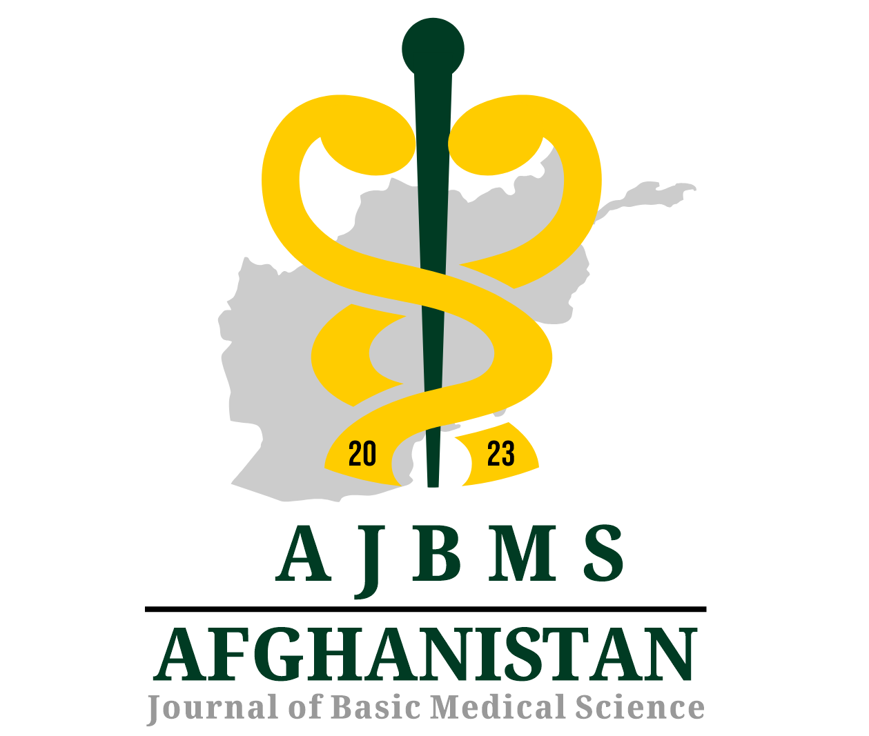
Afghanistan Journal of Basic Medical Science
Conflict of Interest and Authorship Confirmation Form

Please review the following statements for accuracy:

- All authors have contributed to (a) the conception and design, or analysis and interpretation of the data; (b) drafting the manuscript or critically revising it for significant intellectual content; and (c) approving the final version.

- This manuscript has not been submitted to, nor is it currently under review by, any other journal or publishing outlet.

- The authors declare that they have no affiliations with any organization that has a direct or indirect financial interest in the topics addressed in this manuscript.

- The following authors have affiliations with organizations that possess direct or indirect financial interests in the topics discussed in the manuscript:
Commitment Form
Title of the paper:
All individuals listed as authors of this article have made significant, direct intellectual contributions to the research and should be held publicly accountable for it. This manuscript presents work that has not been published elsewhere and is not currently being considered for publication in any other journals.

Corresponding author:
Autours | Name and Last Name | Signature | Date
(All authors must sign this form in the order in which their names appear in the article, and it should be submitted to the editorial office.)

